1. **Create a data base in Hive (DATABASE NAME: BDHS_PROJECT)**
2. **Stock_prices**
3. **Stock_companies**

CREATE DATABASE BDHS_Project1;

CREATE EXTERNAL TABLE Stock_Prices

(

Trading_date DATE,

Symbol STRING,

Open DOUBLE,

Close DOUBLE,

Low DOUBLE,

High DOUBLE,

Volume INT

)

ROW FORMAT DELIMITED FIELDS TERMINATED BY ',';

LOAD DATA INPATH '/user/anabig114231/StockPrices.csv' INTO TABLE stock_prices;

ALTER TABLE stock_prices

SET TBLPROPERTIES ("skip.header.line.count"="1");

select * from stock_prices;

CREATE EXTERNAL TABLE Stock_Companies

(

Symbol STRING,

Company_name STRING,

Sector STRING,

Sub_industry STRING,

Headquarter STRING

)

ROW FORMAT DELIMITED FIELDS TERMINATED BY ',';

LOAD DATA INPATH '/user/anabig114231/Stockcompanies.csv' INTO TABLE stock_companies;

ALTER TABLE stock_companies

SET TBLPROPERTIES ("skip.header.line.count"="1");

select * from stock_companies;

1. **Create a new hive table with the following fields by joining the above two hive tables. Please use appropriate Hive built-in functions for columns (a,b,e and h to l).** • **Trading_year: Should contain YYYY for each record** • **Trading_month: Should contain MM or MMM for each record** • **Symbol: Ticker code** • **CompanyName: Legal name of the listed company** • **State: State to be extracted from headquarters value.** • **Sector: Business vertical of the listed company** • **Sub_Industry: Business domain of the listed company within a sector** • **Open: Average of intra-day opening price by month and year for each listed company** • **Close: Average of intra-day closing price by month and year for each listed company** • **Low: Average of intra-day lowest price by month and year for each listed company** • **High: Average of intra-day highest price by month and year for each listed company** • **Volume: Average of number of shares traded by month and year for each listed company**

CREATE TABLE stock_data as SELECT trading_year, trading_month, sc.symbol, company_name, trim(split(headquarter,"\;")[1])state,sector,sub_industry,open,close,low,high,volume from stock_companies sc, (select symbol, year (trading_date) trading_year, month (trading_date) trading_month, round(avg(open),2) open, round(avg(close),2) close, round(avg(low),2)low, round(avg(high),2) high,round(avg(volume),2)volume from stock_prices group by symbol, month(trading_date), year (trading_date)) sp where sc.symbol = sp.symbol;

select * from stock_data limit 5;

--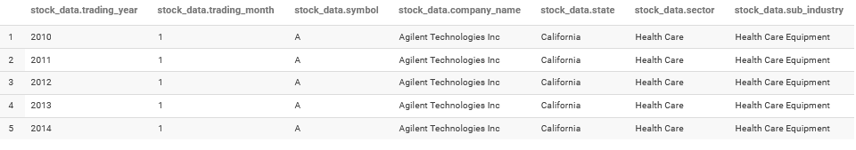

**3) Find the top five companies that are good for investment**

create table stock_table1 as select company_name,min(trading_year)min_year, max(trading_year)max_year, min(trading_month)min_month,max(trading_month)max_month from stock_data group by company_name;

select stock_start.company_name,((close-open)/open)*100 growth_percent from (select t1.company_name, open from stock_data sd, stock_table1 t1 where sd.trading_year = t1.min_year and sd.trading_month = t1.min_month and sd.company_name = t1.company_name)stock_start,(select t1.company_name, close from stock_data sd, stock_table1 t1 where sd.trading_year = t1.max_year and sd.trading_month = t1.max_month and sd.company_name = t1.company_name) stock_end where stock_start.company_name = stock_end.company_name SORT BY growth_percent desc limit 5;

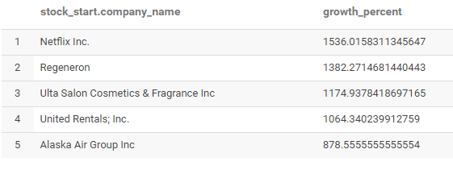

1. **Show the best-growing industry by each state, having at least two or more industries mapped**

CREATE table stock_table_2 as select state, sub_industry,stock_start.company_name, ((stock_end.close-stock_start.open)/stock_start.open)*100 growth_percent from(SELECT t1.company_name, open from stock_data sd, stock_table1 t1 where sd.trading_year = t1.min_year and sd.trading_month =t1.min_month and sd.company_name =t1.company_name)stock_start, (select t1.company_name, close from stock_data sd, stock_table1 t1 where sd.trading_year = t1.max_year and sd.trading_month = t1.max_month and sd.company_name = t1.company_name)stock_end, (select company_name, state, sub_industry from stock_data group by company_name, state, sub_industry) sd where stock_end.close-stock_start.open)>0 and stock_start.company_name = stock_end.company_name and sd.company_name = stock_start.company_name;

select * from stock_table_2 limit 5;

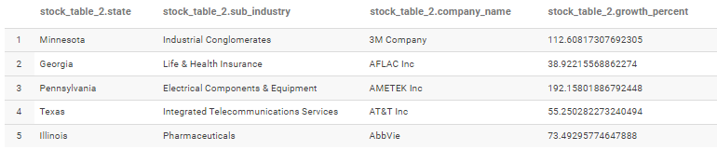

create table stock_tbl_3 as select state, sub_industry, avg(growth_percent) ind_growth from stock_table_2 group by state, sub_industry having count(sub_industry>=2); select * from stock_tbl3 limit 10;

select t3.state, sub_industry, ind_growth from stock_tbl_3 t3, (select state, max(ind_growth) max_growth from stock_tbl_3 group by state) max_ind where max_ind.state = t3.state and t3.ind_growth = max_ind.max_growth;

1. **For each sector find the following.**

**• Worst year**

**• Best year**

CREATE table stock_table4 as select open.sector,open.trading_year,(close-open)growth from(select sector,trading_year,avg(open) open from stock_data where trading_month = 1 group by sector, trading_year) open,(select sector, trading_year, avg(close) close from stock_data where trading_month = 12 group by sector, trading_year) close where open.sector = close.sector and open.trading_year = close.trading_year;

select * from stock_table4 limit 5;

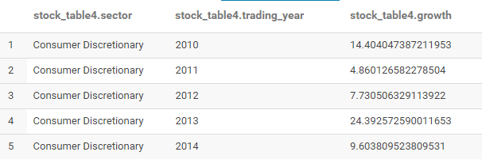

**WORST YEAR**

select x.sector , x.trading_year, x.growth from stock_table4 x,(select sector, min(growth) growth from stock_table4 group by sector)y where x.sector = y.sector and x.growth = y.growth;

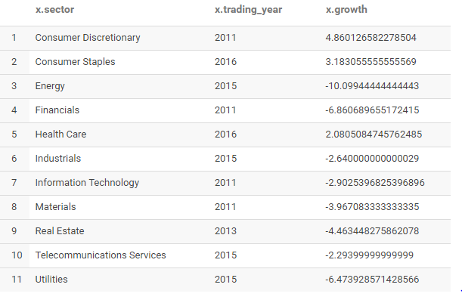

**BEST YEAR**

select a.sector,a.trading_year, a.growth from stock_table4 a, (select sector, max(growth) growth from stock_table4 group by sector) b where a.sector = b.sector and a.growth = b.growth;

